Betoniera Trakker – Iveco 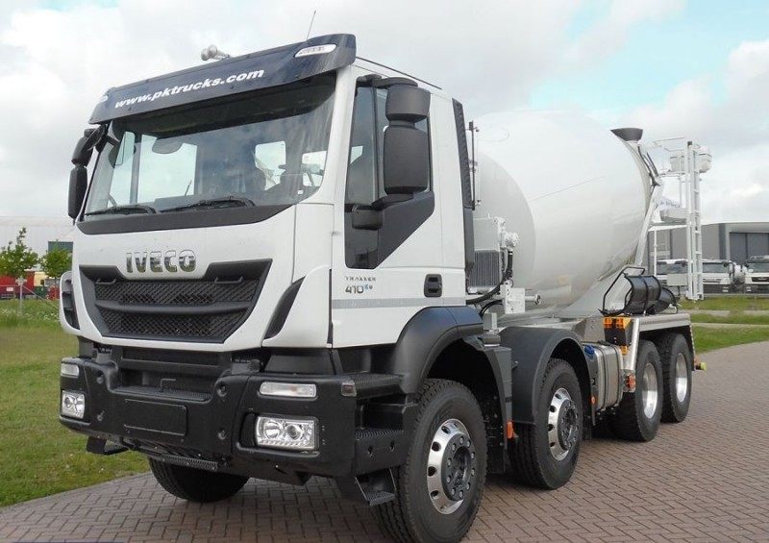

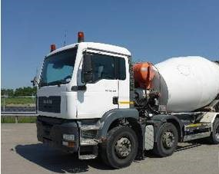 TGA32,350 8\*4 BB – MAN

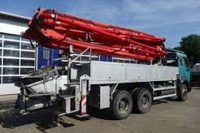 Actros 2631 - Mercedes-Benz

R420LA4X2MNA/R420 – Scania 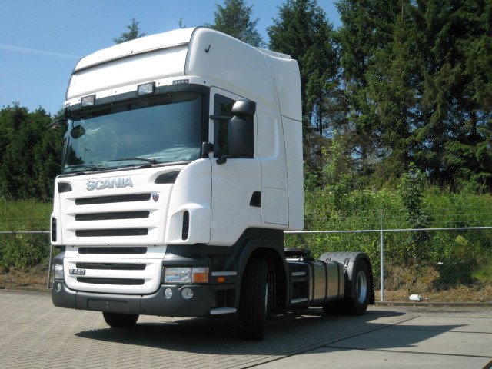

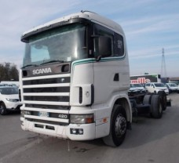 R124LA4\*2NA420 – Scania

R400LA4X2MNA - SCANIA 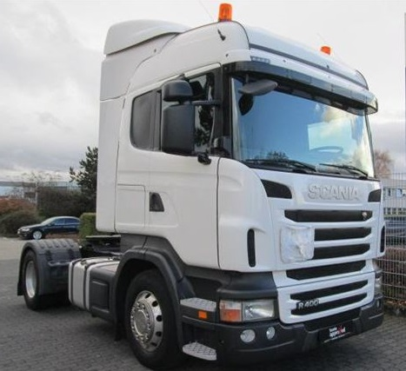

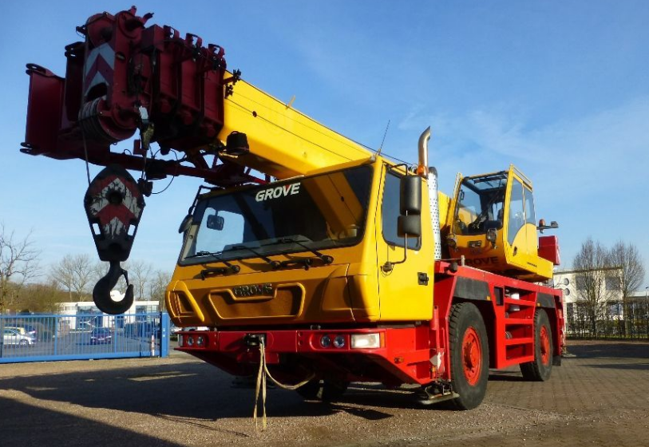 Macara mobila Grove – GMX2035E

Liebherr - Macara LTM1030 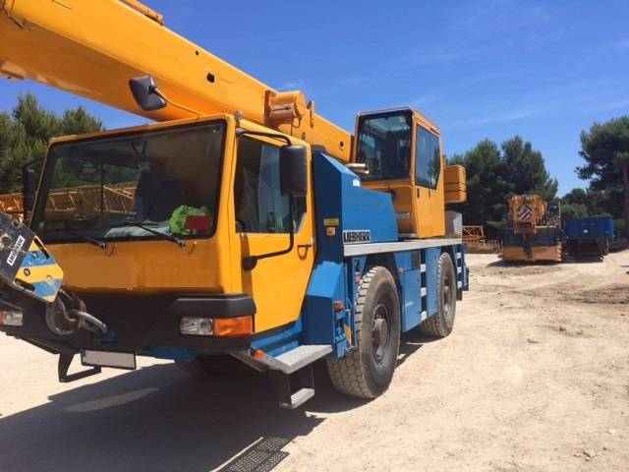

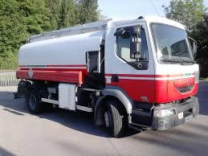 Renault - Cisterna MIDLUM 220 DCI

Unimog + Lama+ Sararita 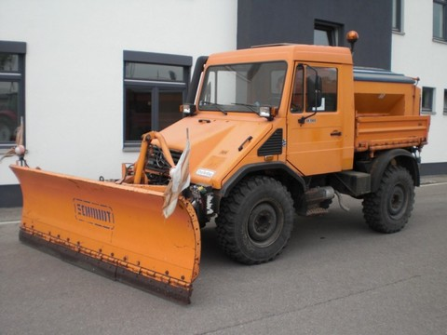

Mercedes-Benz - TYP 408/10 U900

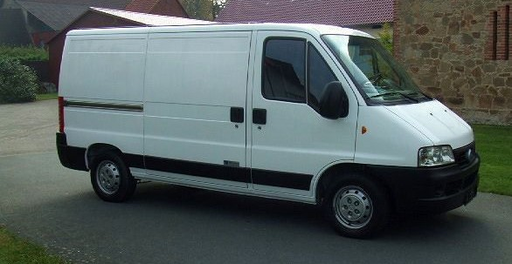 Automobil mixt – Fiat Ducato 2.3 JTD

Autoutilitara – Mercedes-Benz 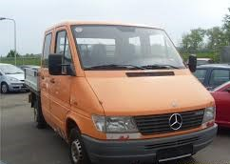

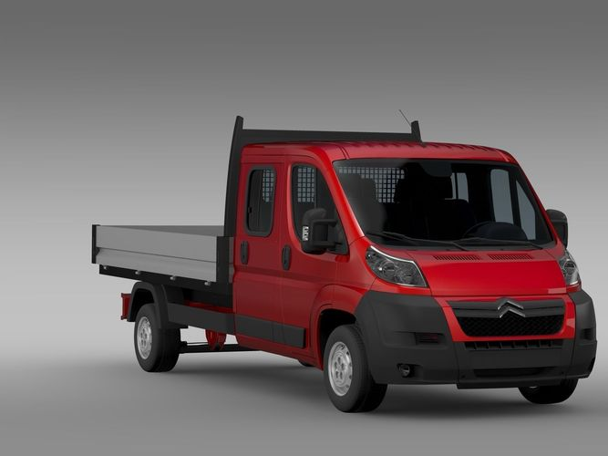

Autoutilitara - Citroen Jumper

Transporter - Volkswagen 7HC 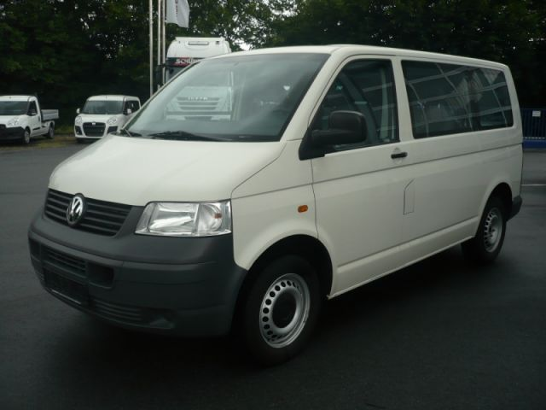

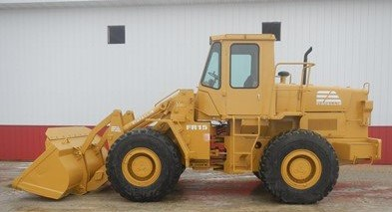 Incarcator frontal – FIATALLIS FR 15

Incarcator frontal - Hanomag 70 E 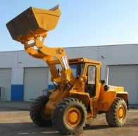

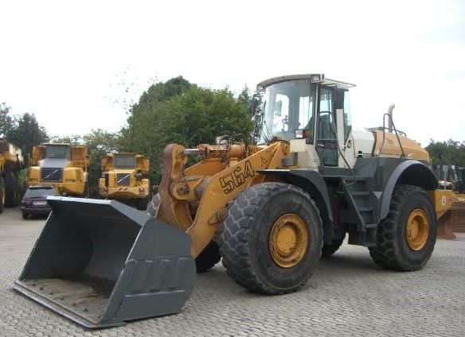 Incarcator frontal - Liebherr L564

Stivuitor STILL DFG 4106 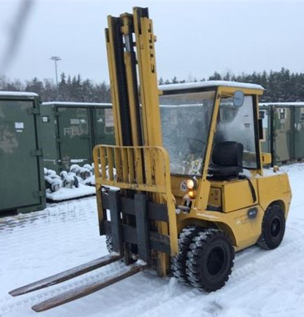

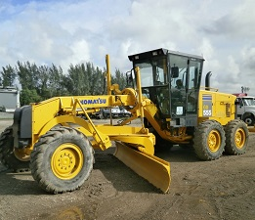 Motogreder – Komatsu GD 555-5

Greder – Caterpillar 140 H 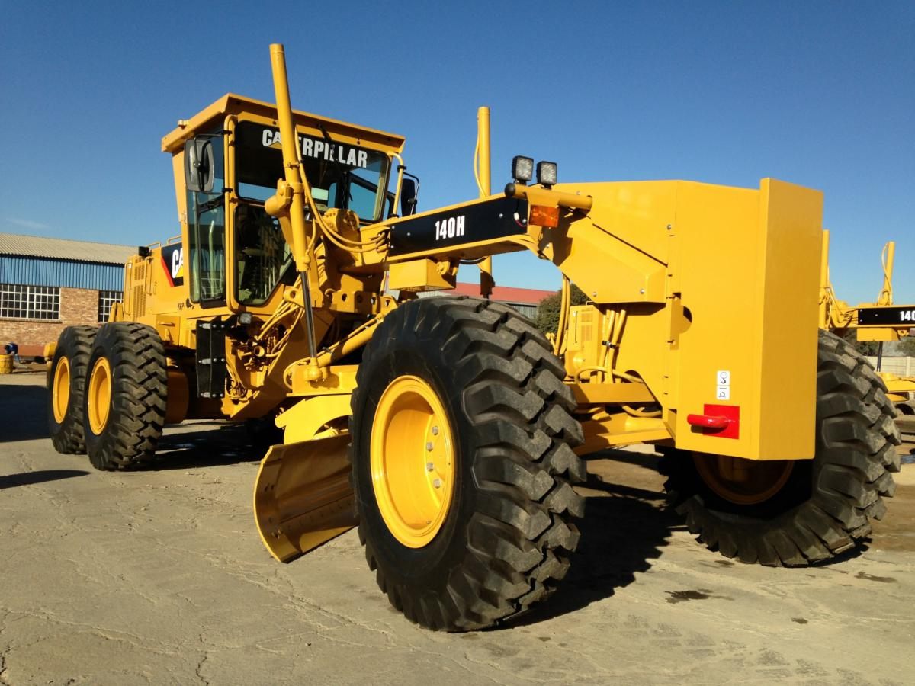

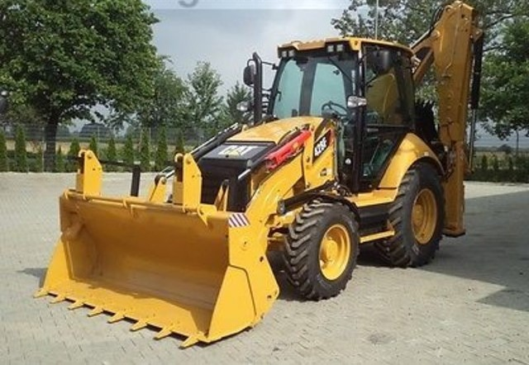 Buldoexcavator – Caterpillar 428F

Buldoexcavator – Caterpillar 427F2 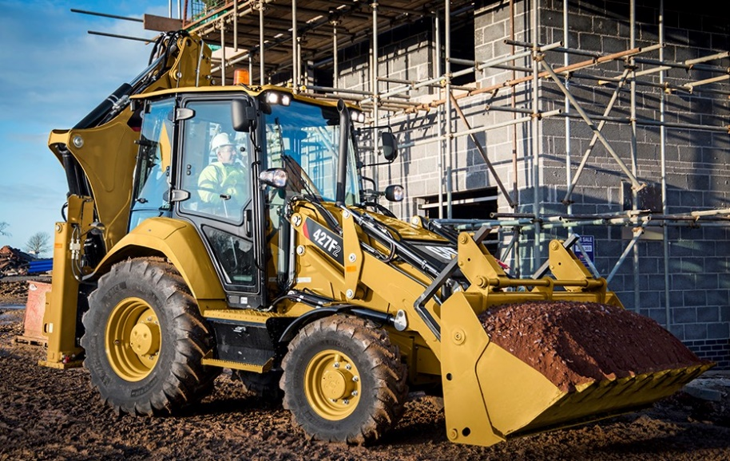

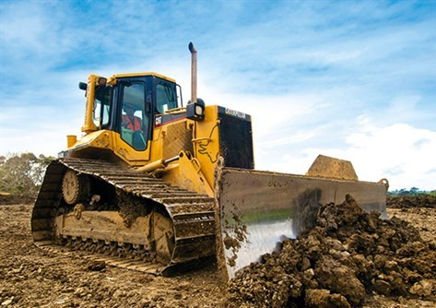 Buldozer – Caterpillar D6M

Buldozer – Caterpillar D6M LGP 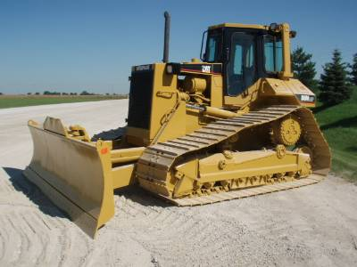

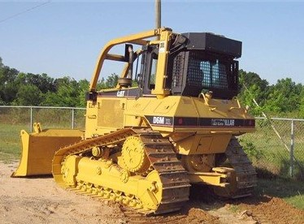 Buldozer – Caterpillar D6M XL

Cilindru compactor – Caterpillar 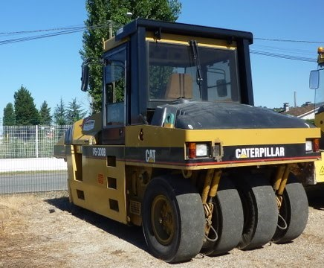

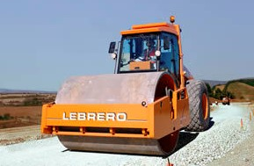 Cilindru compactor mixt – Lebrero

Cilindru compactor – Terex TV1200 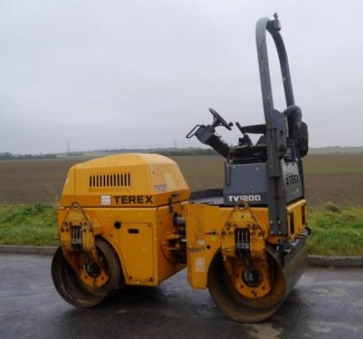

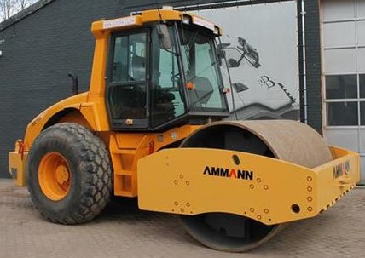 Cilindru compactor mixt – AMMANN

Cilindru compactor mixt – Bomag BW 138 AC 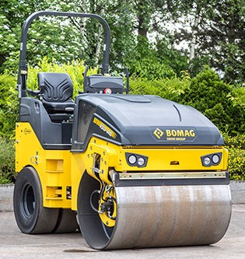

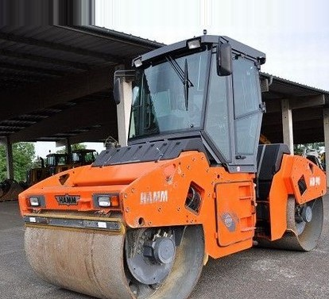 Cilindru compactor Hamm – HD 90

Cilindru compactor Hamm – HD 110 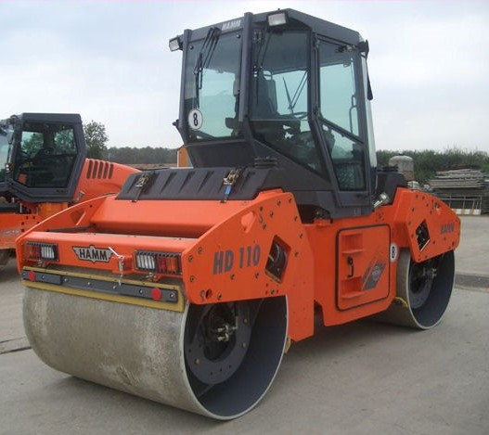

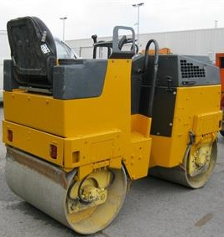 Cilindru compactor – Bomag BW 80 AD

Cilindru compactor manual – Bomag BW 65 HS 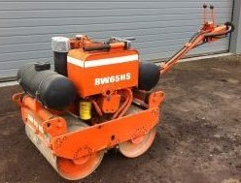

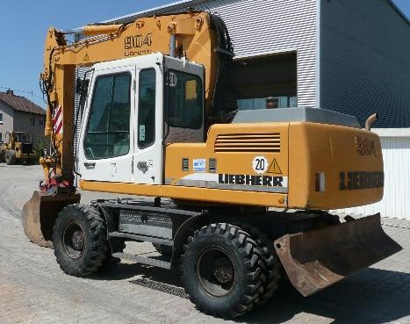 Excavator pe pneuri - Liebherr 904 Litronic

Excavator pe pneuri – Liebherr A 900 B 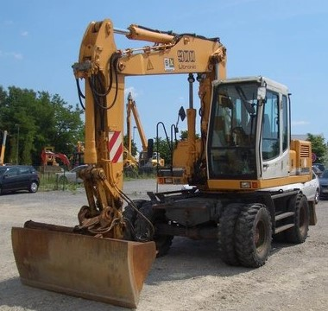

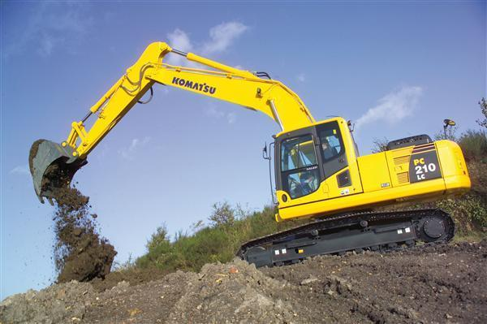 Excavator pe senile – Komatsu PC 210 LC

Excavator pe senile – Komatsu PC 210-6 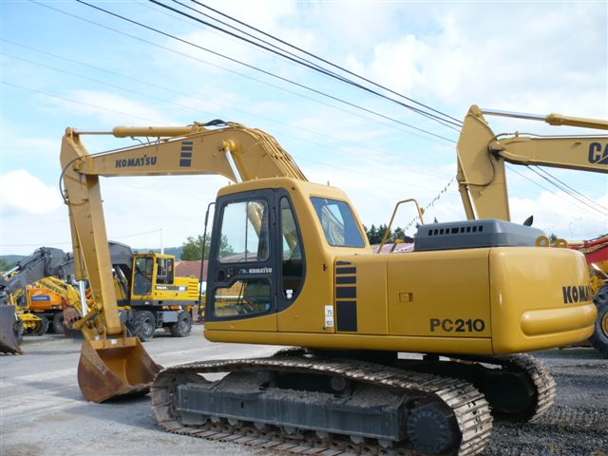

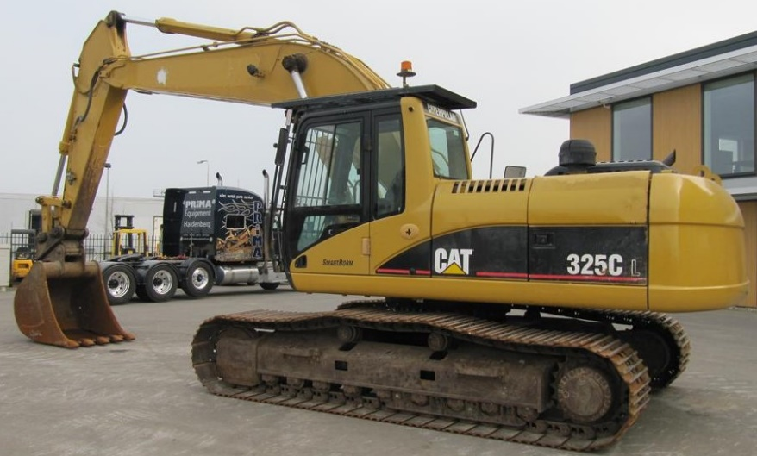 Excavator pe senile – Caterpillar 325 C L

Excavator pe senile – Caterpillar 324 D L 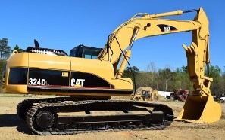

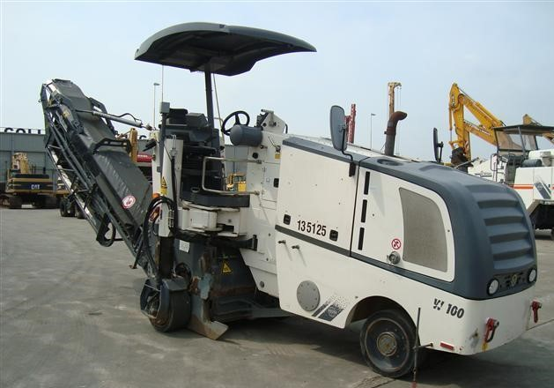 Freza asfalt – Wirtgen W100

Freza asfalt – Bitelli SF 101 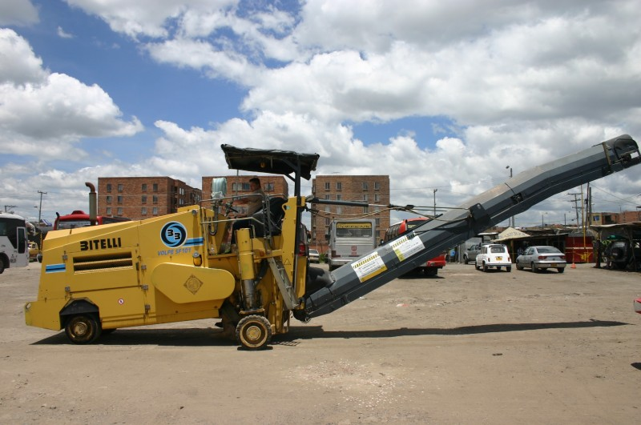

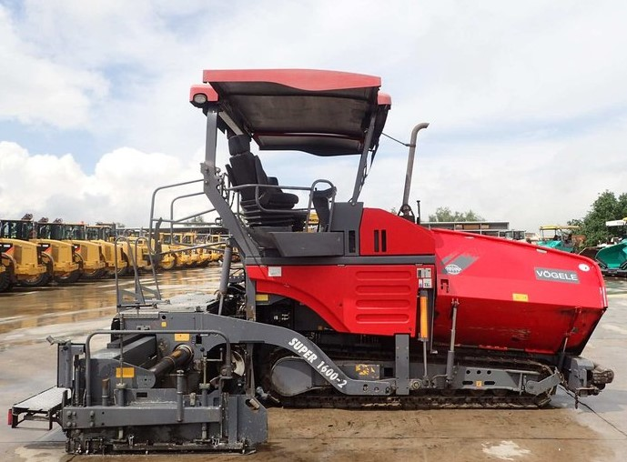 Finisor – Vogele Super 1600-2

Finisor – Vogele Super 800 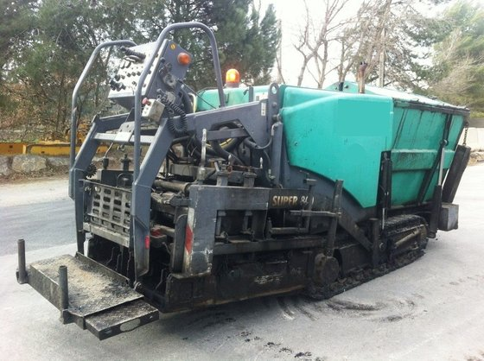

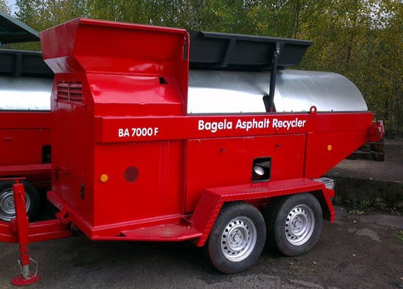 Reciclator asfalt – BAGELA BA7000F

Foreza – Wirth Ecodril 18 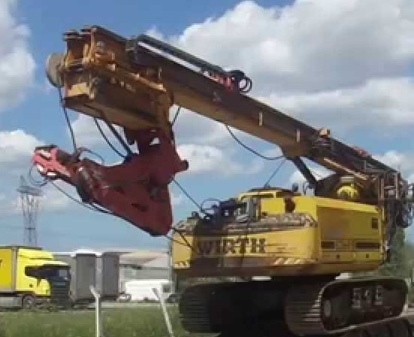

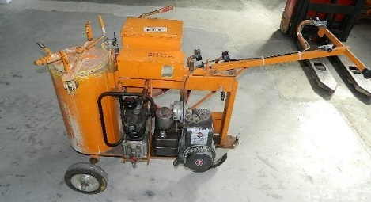 Utilaj de marcat asfalt – Hofmann H8

Motocompresor mobil – KASER M43 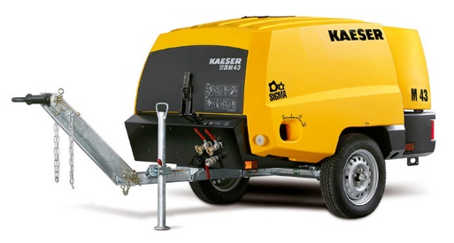

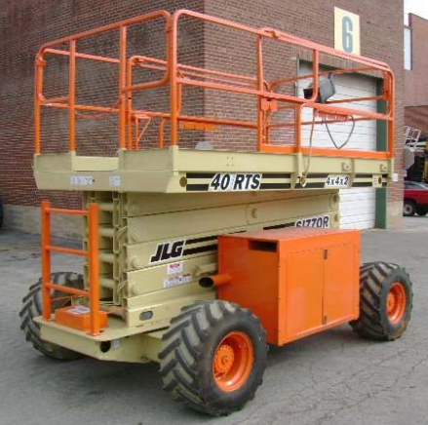 Nacela cu platforma – JLG 40RTS

Platforma articulate – Genie Z-45/25 RT 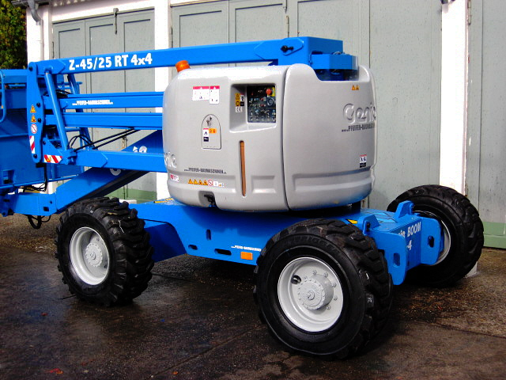

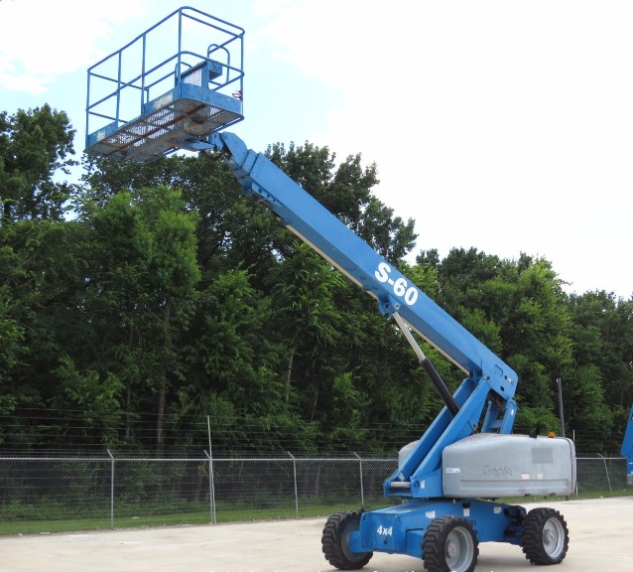 Platforma telescopica – Genie S-60

Platforma tijera electrica – Genie GS2646 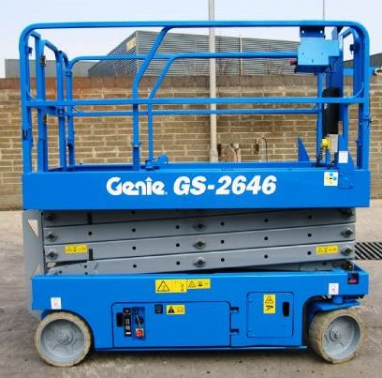

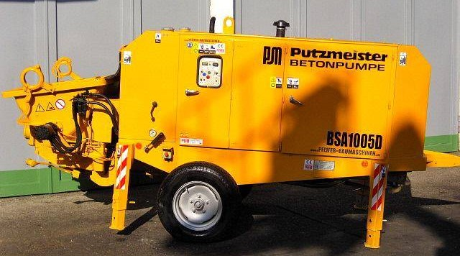 Pompa beton – Putzmeister BSA 1005 D

Concasor piatra – Pegson 1100x650 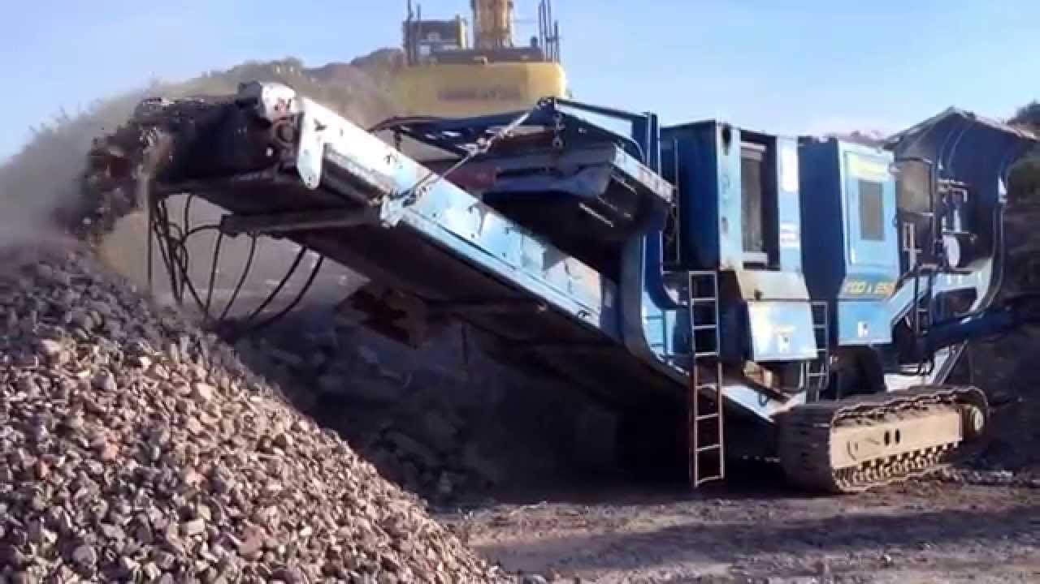

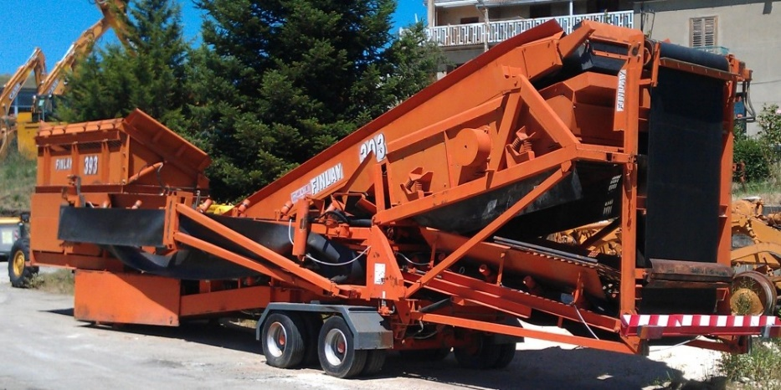 Statie sortare mobila – Finay 393 C

Repartizor agregate – DG 1500 